Software Documentation

1. Software Overview
What does the software do?
This program acts as the main controller for the arcade machine. It sets a 45-second game timer as soon as it powers on. During those 45 seconds, it continuously reads 8 distinct buttons to drive four separate DC motors. It handles the complex "CoreXY" mixing required to drive the X and Y motors together for directional travel, controls a dedicated Z-axis motor for lifting/lowering, and controls a final motor to open and close the claw. Once the timer expires, it completely locks the system to end the game.
Platforms used:
MicroPython running on an ESP32 microcontroller.

2. System Logic
Initialize: The ESP32 assigns its pins, setting eight pins as button inputs (with internal pull-up resistors) and twelve pins as motor outputs (using PWM for speed control). It also starts a master game timer.
Timer Check: The code checks how much time has passed. If 45 seconds have elapsed, it triggers a "TIME UP" state, instantly stops all motors, and traps the code in a dead loop so no more buttons can be pressed.
Read XY Buttons (CoreXY): If the timer is still running, it checks the four directional buttons. If one is pressed, it sends full power to both Motor 1 and Motor 2 in specific forward/backward combinations to move the claw left, right, up, or down.
Read Z-Axis Buttons: It checks the dedicated Z-up and Z-down buttons. If pressed, it drives Motor 3 in the corresponding direction to raise or lower the claw string.
Read Claw Buttons: It checks the claw open and close buttons. If pressed, it drives Motor 4 to pinch or release.
Default Stop State: If you let go of a button, the code automatically sends a "zero speed" command to that specific motor, stopping its movement immediately.

3. Flowchart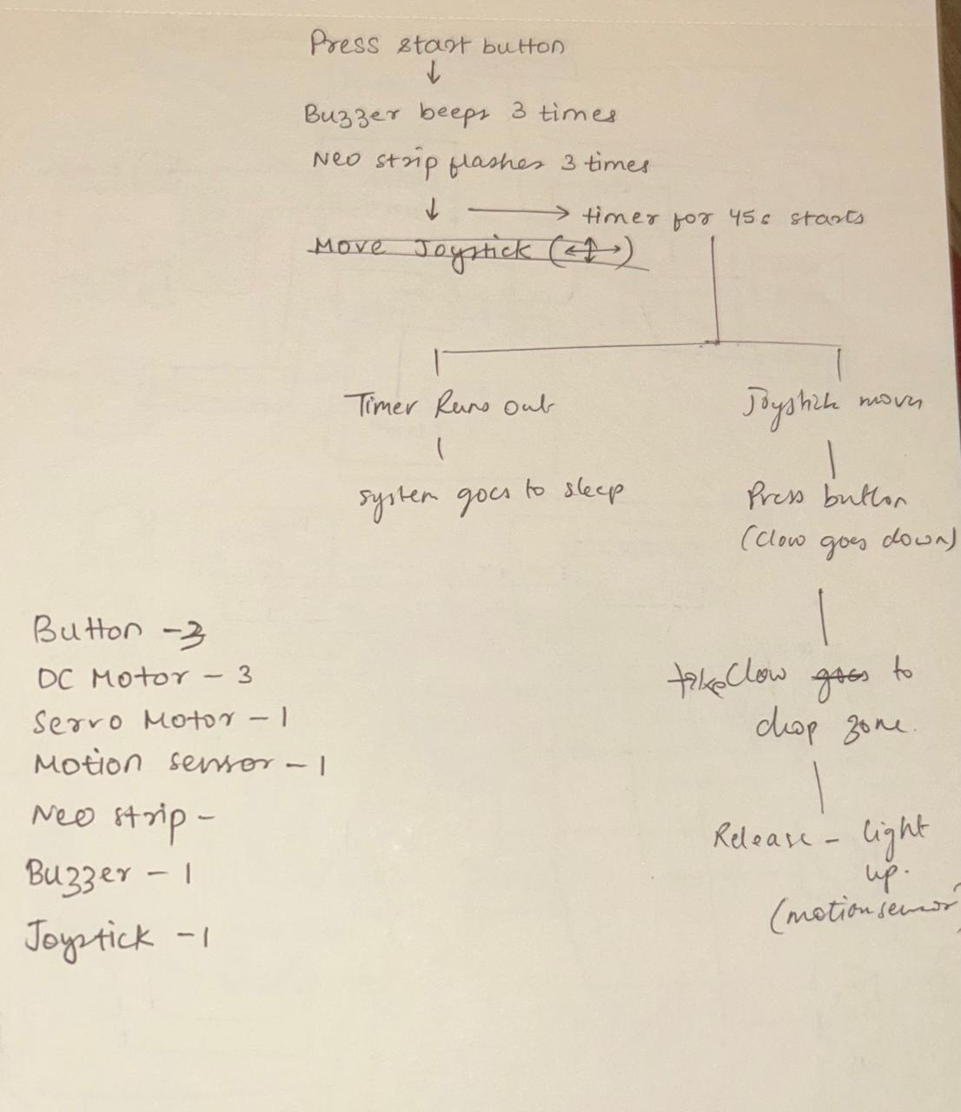
Visual representation of logic – Initial Idea – A few changes took place i.e. use of buttons instead of joystick, removal of motion sensor and replacement of servo motor with dc motor.

4. Code – Final
from machine import Pin, PWM
import time

# BUTTONS
pb_left = Pin(12, Pin.IN, Pin.PULL_UP)
pb_right = Pin(4, Pin.IN, Pin.PULL_UP)
pb_down = Pin(5, Pin.IN, Pin.PULL_UP)
pb_up = Pin(18, Pin.IN, Pin.PULL_UP)

pb_z_up = Pin(35, Pin.IN, Pin.PULL_UP)
pb_z_down = Pin(16, Pin.IN, Pin.PULL_UP)

pb_claw_open = Pin(17, Pin.IN, Pin.PULL_UP)
pb_claw_close = Pin(19, Pin.IN, Pin.PULL_UP)

# MOTOR 1 (X)
in1 = Pin(26, Pin.OUT)
in2 = Pin(27, Pin.OUT)
en1 = PWM(Pin(14), freq=1000)

# MOTOR 2 (Y)
in3 = Pin(25, Pin.OUT)
in4 = Pin(33, Pin.OUT)
en2 = PWM(Pin(32), freq=1000)

# MOTOR 3 (Z)
in5 = Pin(21, Pin.OUT)
in6 = Pin(22, Pin.OUT)
en3 = PWM(Pin(23), freq=1000)

# MOTOR 4 (CLAW)
in7 = Pin(13, Pin.OUT)
in8 = Pin(15, Pin.OUT)
en4 = PWM(Pin(27), freq=1000)

# SETTINGS
max_speed = 1023
GAME_TIME = 45 # seconds

start_time = time.time()

def move_motor(in1, in2, en, direction, speed):
if direction == 1:
in1.on()
in2.off()
elif direction == -1:
in1.off()
in2.on()
else:
in1.off()
in2.off()
speed = 0
en.duty(speed)

def stop_all():
move_motor(in1, in2, en1, 0, 0)
move_motor(in3, in4, en2, 0, 0)
move_motor(in5, in6, en3, 0, 0)
move_motor(in7, in8, en4, 0, 0)

while True:
elapsed = time.time() - start_time

# TIME OVER
if elapsed >= GAME_TIME:
print("TIME UP - SYSTEM LOCKED")

stop_all()

# SYSTEM LOCKED
while True:
stop_all()
time.sleep(1)

# XY MOVEMENT
if pb_left.value() == 0:
move_motor(in1, in2, en1, -1, max_speed)
move_motor(in3, in4, en2, -1, max_speed)
print("left")

elif pb_right.value() == 0:
move_motor(in1, in2, en1, 1, max_speed)
move_motor(in3, in4, en2, 1, max_speed)
print("right")

elif pb_down.value() == 0:
move_motor(in1, in2, en1, 1, max_speed)
move_motor(in3, in4, en2, -1, max_speed)
print("down")

elif pb_up.value() == 0:
move_motor(in1, in2, en1, -1, max_speed)
move_motor(in3, in4, en2, 1, max_speed)
print("up")

else:
move_motor(in1, in2, en1, 0, 0)
move_motor(in3, in4, en2, 0, 0)

# Z AXIS
if pb_z_up.value() == 0:
move_motor(in5, in6, en3, 1, max_speed)
print("Z up")

elif pb_z_down.value() == 0:
move_motor(in5, in6, en3, -1, max_speed)
print("Z down")

else:
move_motor(in5, in6, en3, 0, 0)

# CLAW
if pb_claw_open.value() == 0:
move_motor(in7, in8, en4, 1, max_speed)
print("Claw opening")

elif pb_claw_close.value() == 0:
move_motor(in7, in8, en4, -1, max_speed)
print("Claw closing")

else:
move_motor(in7, in8, en4, 0, 0)

time.sleep(0.05)

Codes to test components -
Claw Code
from machine import Pin, PWM
import time

# L298N Motor Driver Setup
speed_pin = PWM(Pin(19))
speed_pin.freq(1000)

dir_pin_1 = Pin(13, Pin.OUT)
dir_pin_2 = Pin(15, Pin.OUT)

MOTOR_SPEED = 1023

# Main Loop
while True:

# Open claw
print("Opening Claw...")
dir_pin_1.value(1)
dir_pin_2.value(0)
speed_pin.duty(MOTOR_SPEED)
time.sleep(0.8)
dir_pin_1.value(0)
dir_pin_2.value(0)
speed_pin.duty(0)

time.sleep(2)

# Close claw
print("Closing Claw...")
dir_pin_1.value(0)
dir_pin_2.value(1)
speed_pin.duty(MOTOR_SPEED)
time.sleep(0.6)
dir_pin_1.value(0)
dir_pin_2.value(0)
speed_pin.duty(0)

time.sleep(2)

Test code for joystick and motors
from machine import Pin, PWM, ADC
import time

joy_x = ADC(Pin(34))
joy_y = ADC(Pin(35))
joy_x.atten(ADC.ATTN_11DB)
joy_y.atten(ADC.ATTN_11DB)

in1 = Pin(27, Pin.OUT)
in2 = Pin(26, Pin.OUT)
ena = PWM(Pin(14))
ena.freq(1000)

in3 = Pin(25, Pin.OUT)
in4 = Pin(33, Pin.OUT)
enb = PWM(Pin(23))
enb.freq(1000)

MIN_DUTY = 350
MAX_DUTY = 950

time.sleep(3)
center_x = joy_x.read()
center_y = joy_y.read()

while True:
raw_x = joy_x.read()
raw_y = joy_y.read()

x_val = 0.0 if abs(raw_x - center_x) < 200 else (raw_x - center_x) / (float(center_x) if raw_x < center_x else (4095.0 - center_x))
y_val = 0.0 if abs(raw_y - center_y) < 200 else -((raw_y - center_y) / (float(center_y) if raw_y < center_y else (4095.0 - center_y)))

a_mix = max(-1.0, min(1.0, y_val + x_val))
b_mix = max(-1.0, min(1.0, y_val - x_val))

duty_a = 0 if a_mix == 0.0 else int(MIN_DUTY + abs(a_mix) * (MAX_DUTY - MIN_DUTY))
duty_b = 0 if b_mix == 0.0 else int(MIN_DUTY + abs(b_mix) * (MAX_DUTY - MIN_DUTY))

if a_mix > 0:
in1.on(); in2.off()
elif a_mix < 0:
in1.off(); in2.on()
else:
in1.off(); in2.off()
ena.duty(duty_a)

if b_mix > 0:
in3.on(); in4.off()
elif b_mix < 0:
in3.off(); in4.on()
else:
in3.off(); in4.off()
enb.duty(duty_b)

time.sleep(0.1)

Code for joystick – picked from forum about PS2 joysticks.1
from machine import Pin, ADC
from time import sleep

# Joystick axes on ADC1 pins
x_axis = ADC(Pin(34)) # VRx
y_axis = ADC(Pin(35)) # VRy

# Set attenuation for full 0–3.3V range
x_axis.atten(ADC.ATTN_11DB)
y_axis.atten(ADC.ATTN_11DB)

# Joystick button on GPIO32
button = Pin(26, Pin.IN, Pin.PULL_UP)

print("Starting Joystick Check...")

while True:
x_val = x_axis.read()
y_val = y_axis.read()
z_val = button.value()
#print(f"X: {x_val:5} | Y: {y_val:5}")

print(f"X: {x_val:5} | Y: {y_val:5} | Button: {'Pressed' if z_val == 0 else 'Released'}")
sleep(0.2)

DC motor testing codes
from machine import Pin, PWM
import time

#Motor A
in1 = Pin(27, Pin.OUT)
in2 = Pin(26, Pin.OUT)
ena = PWM(Pin(14))
ena.freq(1000)
ena.duty(1023)

# Motor B
in3 = Pin(25, Pin.OUT)
in4 = Pin(33, Pin.OUT)
enb = PWM(Pin(23))
enb.freq(1000)
enb.duty(1023)

# # Motor C
# in5 = Pin(4, Pin.OUT)
# in6 = Pin(5, Pin.OUT)
# enc = PWM(Pin(2))
# enc.freq(1000)
# enc.duty(512)

while True:
# Motor A forward/back
in1.on(); in2.off()
# time.sleep(3)
# in1.off(); in2.on()
# time.sleep(3)
# in1.off(); in2.off() # stop motor A

# Motor B forward/back
in3.on(); in4.off()
# time.sleep(3)
# in3.off(); in4.on()
# time.sleep(3)
# in3.off(); in4.off() # stop motor B

# # Motor C forward/back
# in5.on(); in6.off()
# time.sleep(3)
# in5.off(); in6.on()
# time.sleep(3)
# in5.off(); in6.off() # stop motor C
Initial servo motor code
from machine import Pin, PWM
import time
moto =PWM(Pin(32))
moto.freq(50)
while True:
moto.duty(35)
time.sleep(0.2)
moto.duty(110) #0 degree = 18
time.sleep(0.2)

